BAR GRAPH WORKSHEET
CLASS: VIII
SUBJECT: MATHEMATICS
- The Bar Graph Which Shows Number Of Books Sold in the year 1997 and 1998
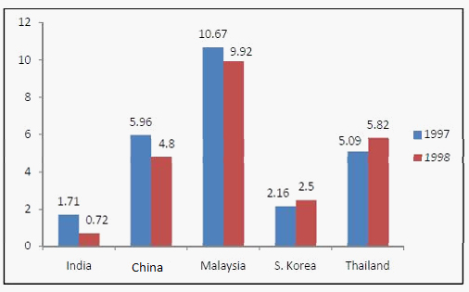
- How many books are sold in Thailand in 1998?
- How many much books are sold in China in both years?
- What is the average of books sold in 1997?
- What is the average of books sold in India totally?
- Mr. Paul owns two kitchen appliance stores. He compares the sales in the two stores. Use the bar graph to answer the following questions:
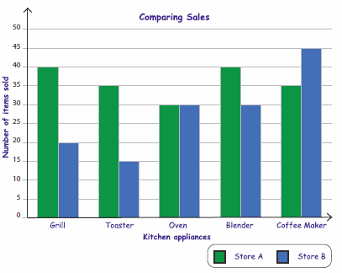
- Which store sold maximum number of oven?
- Which store sold least number of coffee maker?
- What is the difference on the sale of Grill in the two stores?
- What is the total number of Toaster sold in two stores?
- Represent the data on a bar graph.

year | 2015 | 2016 | 2017 | 2018 | 2019
English | 30 | 40 | 20 | 25 | 40
science | 25 | 40 | 25 | 35 | 20

i. Find the ratio of sale of English to Science books in the year 2017
ii. When was the highest number of units sold for each subject?
iii. What is the difference in the number of sales of English and Science books in the year 2018?
- Represent the data on a bar graph.
week | Number of cars
I | 600
II | 870
III | 750
IV | 400
V | 900

i. Find the ratio of cars sold in fourth week to that of in fifth week.
ii. Which week had sales of less than 500 cars?
iii. What is the difference in number of cars sold in the first week and the fifth week?

